MSRI Analyst - Writing Test

Please use the attached data to prepare a brief writing sample with the following prompts - maximum 1.5 hours

Hello, thank you for taking the time to discuss your skills and experience with us during the interview round. For the final step in the interview process, we are asking all finalists to complete this short analysis and writing prompt to gauge your analytical and writing skills.

We have included a cleaned dataset, which comes from an impact evaluation that iDE conducted in Vietnam of a micro-irrigation technology project. The data was collected from households that purchased irrigation technologies from a retailer (Treatment group), and farmers that did not purchase irrigation technologies (Control group). We gathered information on their crop production, including their costs and earnings. Using this data, please prepare a nicely formatted and concise document that contains at least the following:

1. Basic descriptive analysis on the following variables where you describe the sample using at least one table, one figure and written text - please disaggregate the data by Treatment Group (variable: treat).
   1. How many observations and where they come from geographically (variable name:
   2. Household Size (variable name: hh_size)
   3. PPI score (variable name: ppi_raw)
   4. Poverty status (variable name: q2_9_hh_status)
   5. Land holdings for rice (variable name: q3_1a_land_rice)
   6. Land holding for vegetables (variable name: q3_1b_land_veg)
   7. Land holding for fruit (variable name: q3_1c_land_fruit)
2. One paragraph interpreting the descriptive analysis you completed in Step #1 and what the results mean for the reader.
3. Estimate what the treatment effect is on the following outcomes (i.e., the difference between Treatment group and Control group) and use a t-test to determine whether the result is statistically significant. Prepare a table showing the treatment effect and the significance level of the test.
   1. Total crop revenue in PPP (**Purchasing power parity)** (Variable name: profit_total_ppp)
   2. Total crop profit in PPP (variable name: total_profit_ppp)
   3. Total crop profit per m2 (variable name: total_profit_m2_ppp)
4. Final paragraph explaining the treatment effects that you estimated in Step #3, and what the results indicate for the program and for iDE.

You are welcome to include any additional analyses and written content that you would like. Please do not exceed four pages in total. This is your opportunity to impress us with your analysis and communication capabilities.

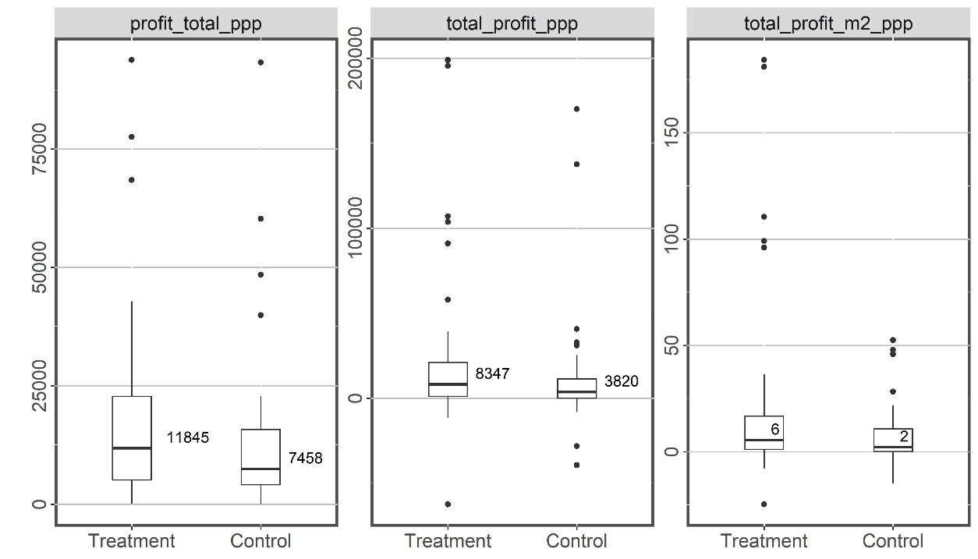

 two group are no significantly different from each other in terms of all 4 variables.